## Advanced-Visio-Features-QRC

## Introduction

## As the EMAF Visio templates use several advanced Visio features which alleviates each architect figuring out how to use and implementing these features themselves, this QRC provides guidance for using these advanced Visio features while using EMAF standard templates.

## Instructions covered within this QRC include how to:

* Accessing EMAF Visio Templates
* Aligning Shapes
* Positioning Shapes
* Using Layers
* Finding and Selecting Shapes by Layer(s)
* Resizing Diagram (Sheets)

* Resizing Background Objects
* Changing Header/Footer data
* Quickly Building Diagrams without Concerns for Page Size or Background Formatting

## Instructions for Accessing EMAF Visio Templates

Note: These instructions use file locations not backed up!!

Files located under **c:\user\my-network-id\LocalData** are not backed up to your **H:** drive, users should periodically copy there working folders to your **H:** drive to prevent losing information in the event of hardware failure.

In **Visio**

1. Open an existing template - **FILE -> New -> Categories**

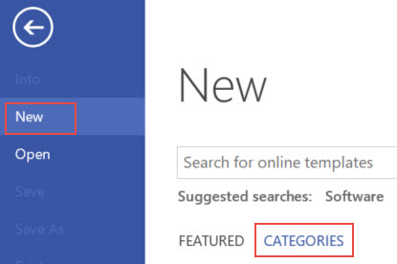

An image for each EMAF template is displayed.

1. For example, select **Business Capability Model Template**

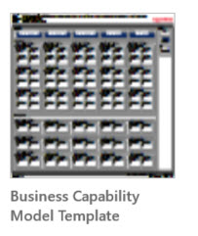

1. Select **Create** option

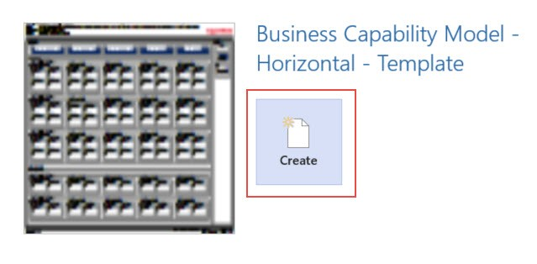

1. Template opens with a generic name **Drawing1**. Select **FILE -> Save As** to save a copy of it for current project on your **work directory** ( other than My Templates)

##### TIP: Create a **My Projects** work directory on File Explorer. Each modeling project can be a sub-directory under **My Projects** directory. The copy of Visio template and associated excel template can be saved on this sub-directory. Example screenshot below.

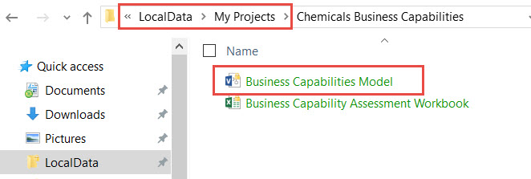

NOTE: Files located under c:\user\my-network-id\LocalData are not backed up to your H: drive.

To prevent loss of data due to hardware failure, users should periodically copy there working folders to your H: drive.

## Instructions for Aligning Shapes

While working with shapes, multiple shapes can be aligned for a crisp look using **HOME -> Align** options

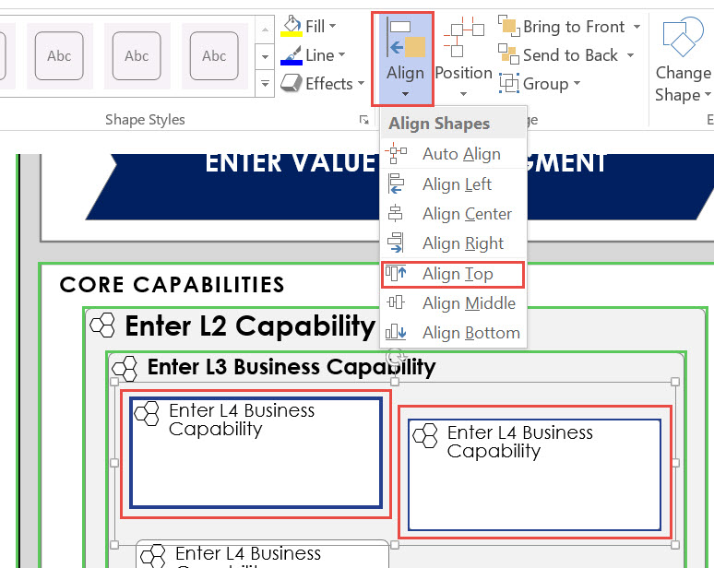

## Instructions for Positioning Shapes

While working with shapes, multiple shapes can be positioned for a crisp look using **HOME -> Position** options

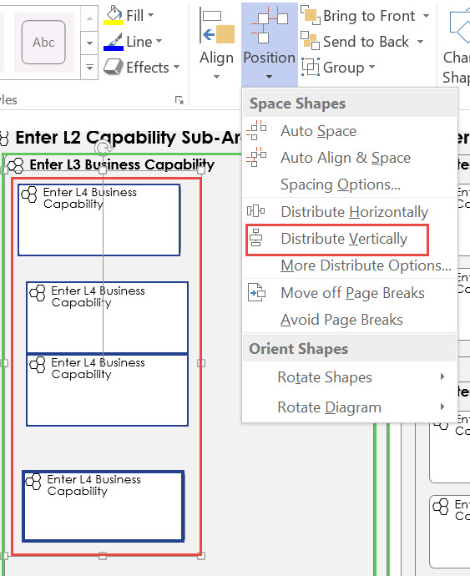

## Instructions for Using Layers

All EMAF Shapes and Templates come pre-configured with standard layer names to allow the architect to manipulate different layers (architecture shapes) to aid the architect work on or communicate the design.

Useful Layer Properties to allowing turn on/off for specified architecture shapes:

* Visible - displaying in diagram
* Print - printing in diagram
* Lock - changes in diagram

1. **Layer Properties** of layers on a diagram can be accessed from **HOME -> Layers -> Layer Properties**

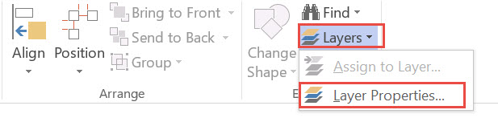

1. On **Layer Properties Window** layers can be **turned on / off** by **Checking / Unchecking** boxes

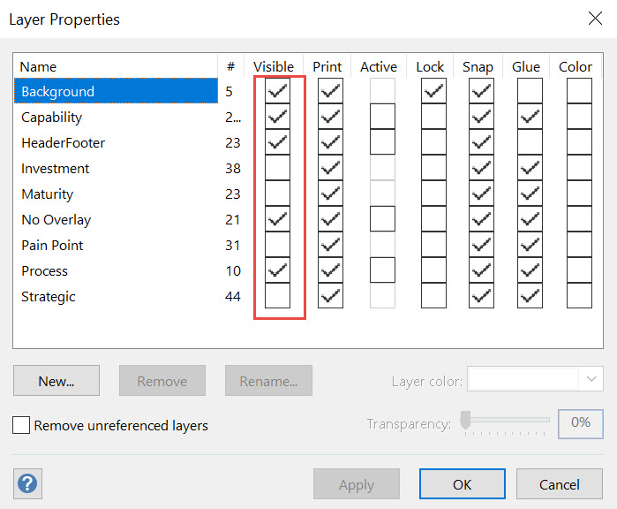

## **Instructions for Finding and Selecting Shapes by Layer(s)**

## **Instructions for Resizing Diagrams (Sheets)**

* Standard Visio methods for resizing a diagram
  + Presets
  + Fit to Drawing
  + Custom
* Resizing using Global Shape Data

Since diagrams can tend to be large and standard page sizes might not be an option, use **Fit to Drawing** option on **DESIGN -> Size** menu item.

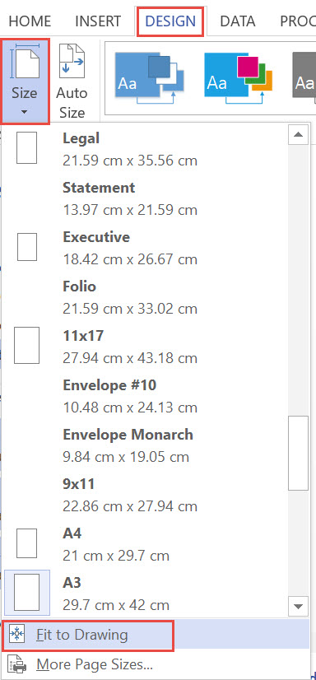

## Instructions for Resizing Bound Background Objects

All Bound Diagrams

Top/Bottom Bound Diagrams

Using Background Shape Data

## Instructions for Resizing Unbound Background Objects

Unbound Background Objects

## Instructions for Changing Header / Footer data

Header / Footer data changes are made on **Shape Data Panel** for it to reflect on diagram.

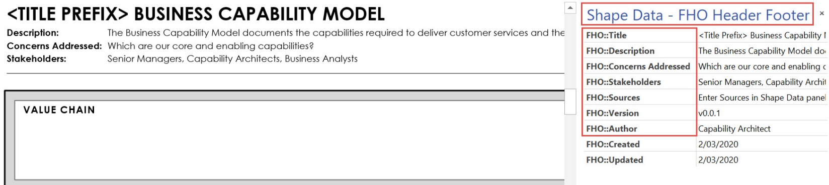

There could be instances where **Description** on Header section of template, could get to be too long (as shown below)



Resize **Description Text Box** to wrap text within the box. The Header section is set to resize accordingly.

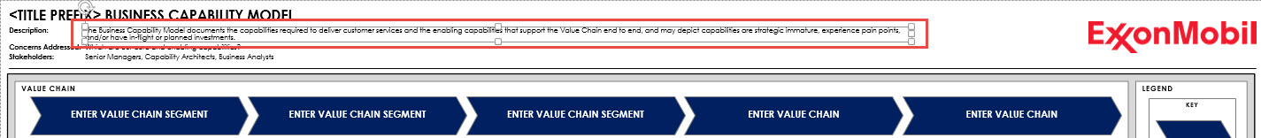

# Instructions for Quickly Building Diagrams without Concerns for Page Size or Background Formatting

Copy one or more pre-linked shapes in the gray buffer outside of diagram (aka pallet) to quickly create this artifact

Use the gray buffer outside of diagram to link shapes to data and arrange the information

Keep 5 mm between shapes

Use alignment tool to quickly align shapes as required: Home->Align

Once diagram is built and formatted, use the ruler to determine the size of page

Resize page: (see Page Shape Data instructions above)

Select shapes and move to the appropriate white generic containers

Adjust diagram further as required